Parth Babbar

yahoo finance

**Introduction:**

Yahoo Finance, founded in January 1997, is one of the most popular platforms for financial news, data, and tools. It is owned by Verizon Media Group and serves a varied audience of individual investors, traders, and financial professionals. This guide gives a full overview of Yahoo Finance's features, tools, and resources, explaining why it is still a popular option for staying up to date on financial markets and managing assets.

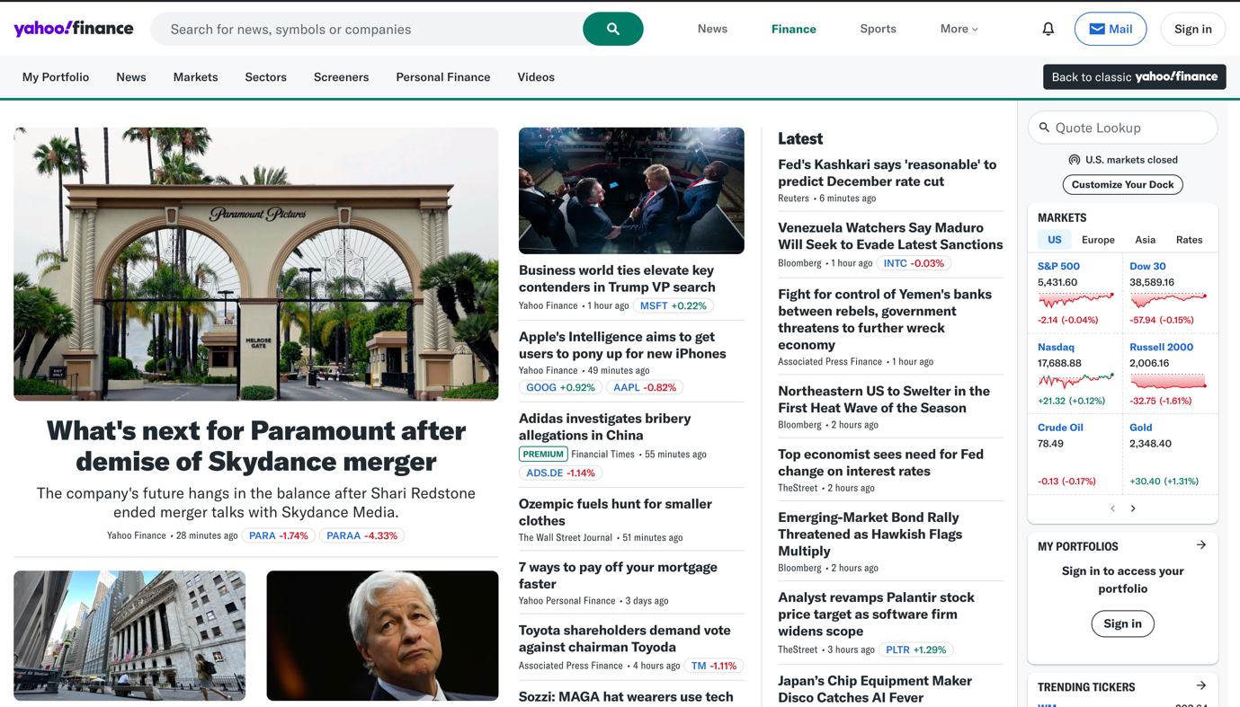

**Features:**

Yahoo Finance provides broad market data for a variety of financial instruments:

1. **Stock Quotes:** It provides critical financial information, such as real-time quotations, which give up-to-date pricing for stocks traded on major exchanges such as the NYSE, NASDAQ, and AMEX. They also contain extensive historical data, which allows for trend analysis and study into prior stock values. Furthermore, market summaries are given every day, summarising market performance with information on the most active stocks, top gainers, and top losers.

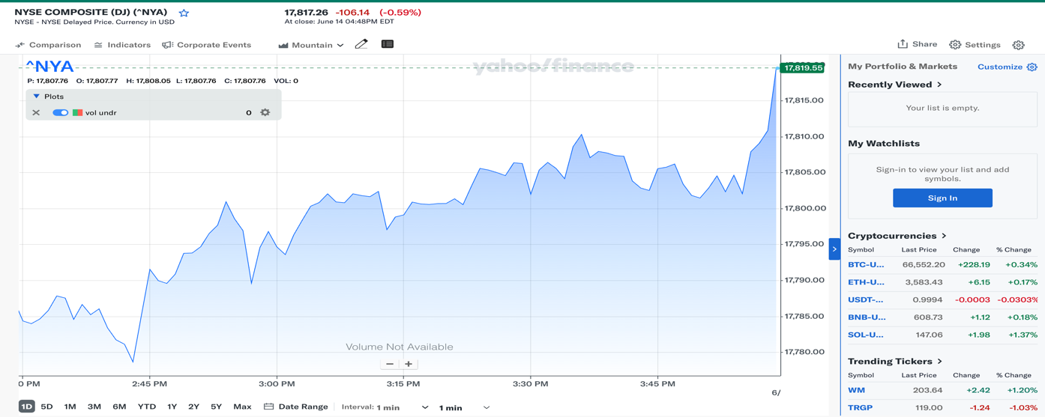

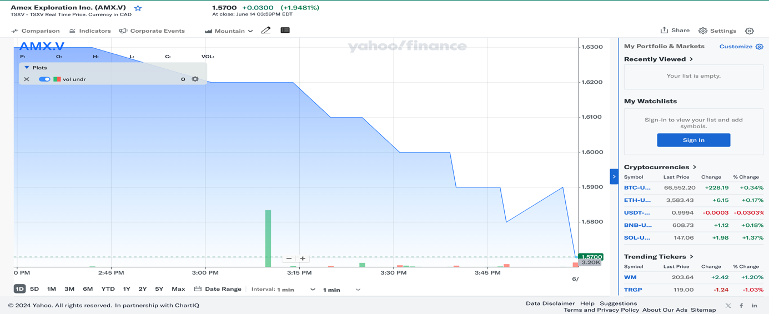

1. **Indices:** Stock market data includes important indexes such as the Dow Jones Industrial Average, S&P 500, NASDAQ Composite, and Russell 2000, which provide insight into overall market patterns. Additionally, global indexes such as the FTSE 100, Nikkei 225, and DAX provide performance data for worldwide markets, allowing for full monitoring of global economic patterns and market movements.
2. **Currencies:** Exchange rate services provide real-time and historical data for key currency pairings, which are critical for tracking currency swings in worldwide markets. Furthermore, currency conversion features enable users to effortlessly compute and convert quantities between other currencies, making international transactions and financial planning easier.
3. **Goods:** Financial data services provide current and historical pricing for important commodities such as gold, silver, crude oil, and natural gas, allowing for thorough market research and investment decisions. They also give in-depth information on commodities futures and options trading, including market expectations and hedging and speculating methods.
4. **Cryptocurrencies:** Cryptocurrency statistics contains prices, market capitalization, and trading volume for key cryptocurrencies such as Bitcoin and Ethereum, giving a comprehensive picture of the market. Furthermore, market news keeps consumers up to date on the most recent events and trends in the cryptocurrency field, allowing them to make timely and educated decisions.

**Tools:**

There are many different tools in Yahoo Finance:

1. **Charts:** It provides extensive charting capabilities with customisable time periods and technical indicators, allowing for detailed visual study of market patterns. They also give comprehensive technical analysis tools such as moving averages, RSI, and MACD to help customers make informed trading decisions based on market data.  
   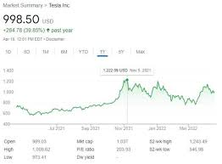
2. **Statements:** Income statements are included in financial reports, and they reflect a company's sales, costs, and profits. Balance sheets provide a picture of a company's financial status by detailing its assets, liabilities, and shareholders' equity. Cash flow statements provide information on a company's cash inflows and outflows from operations, investing, and financing activities, which may be used to analyse liquidity and financial health.  
   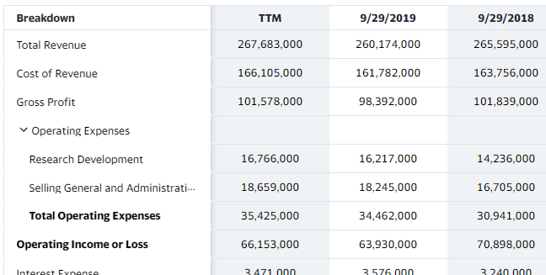
3. **Portfolio Management:** Portfolio trackers allow investors to track and analyse the performance of their investment portfolios and asset allocations. Users may also set up customisable notifications for price movements, news, and key events affecting monitored assets, ensuring they stay informed and respond quickly to market developments.  
   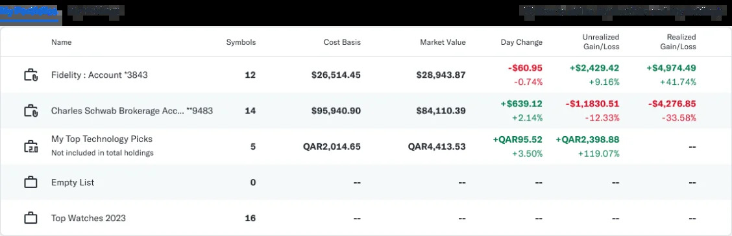
4. **Screeners:** A stock screener allows users to filter stocks based on factors such as market capitalization, P/E ratio, and dividend yield. An ETF screener identifies exchange-traded funds based on performance, fees, and asset class, whereas a mutual fund screener identifies mutual funds that meet specified investing criteria, allowing investors to make better educated decisions.
5. **Calendars:** Financial calendars contain important scheduling information, such as an earnings calendar that lists upcoming earnings reports, an economic calendar that highlights key economic events and indicators such as GDP releases and employment reports, and an IPO calendar that provides information on upcoming and recent initial public offerings. These tools help investors remain up to date on major financial happenings.

**Financial Analysis:**

1. **Research Reports:** Professional financial services provide access to extensive research reports from financial analysts and investment banks, which provide in-depth observations and recommendations. Furthermore, industry analysis papers focus on individual businesses and sectors, identifying trends and opportunities that may help investors make educated decisions within certain market segments.
2. **Analyst Ratings:** Consensus ratings are investment instruments that give average evaluations from many analysts, such as buy, hold, or sell recommendations. They also provide analysts' anticipated price goals for equities, offering investors insight into potential future stock performance based on expert research.
3. **Company Profiles:** Company profiles include thorough business descriptions that outline a company's activities, goods, and services. They also provide information on important executives and board members, providing insight into the leadership team. Furthermore, ownership data includes a split of institutional and insider ownership, providing a more complete understanding of the company's stakeholder structure.

**Knowledgeable Content:**

1. **Forum:** Financial platforms frequently offer discussion boards where users may join community forums to debate stocks, trading techniques, and market movements. These boards encourage investors to collaborate and share their knowledge. Furthermore, Q&A sections allow users to ask questions and receive answers from peers or experts, which improves knowledge and information sharing within the investing community.
2. **Educational Articles & Videos:** Investing platforms offer materials for all skill levels: novices may get articles and videos on fundamental principles and tactics, while expert investors can get in-depth information on technical analysis, options trading, and portfolio management. These materials enable users to make more educated investment decisions and strengthen their strategy.

**Premium Feature:**

Yahoo Finance Premium provides customers with a variety of additional tools and information to help them improve their financial strategy. Subscribers get access to improved charting capabilities for extensive market analysis, in-depth research reports that provide comprehensive insights into companies and sectors, and curated investment ideas to help them explore prospective possibilities. Yahoo Finance Premium also includes exclusive fair value analysis tools, which allow users to analyse companies based on their intrinsic worth, allowing for more educated financial market decisions.  


**Integration:**

Yahoo Finance provides additional functionality with Yahoo Account Integration, giving consumers a more personalised experience by integrating their Yahoo accounts. This connection allows for personalised information and settings depending on individual choices and interests.  
  
Yahoo Finance also offers Brokerage Account Integration, which allows users to link their brokerage accounts directly to the site. This feature allows for seamless portfolio tracking and management, delivering real-time information on investments and transactions through a single interface. It improves ease and efficiency for investors who manage their financial portfolios.

**Trends:**

1. **Economic Indicators:** Recent data show a mixed picture for global economic development, with some countries recovering while others struggling owing to geopolitical tensions and inflationary pressures.
2. **Stock Market Performance:** Investors expect the S&P 500 to grow in 2024. However, market volatility remains a concern owing to persistent economic uncertainty.
3. **Interest Rates:** Although the Federal Reserve has kept interest rates stable, estimates indicate that rates may be decreased later in 2024, affecting investment plans and market dynamics.
4. **Cryptocurrency industry:** The cryptocurrency industry is constantly evolving, with substantial changes in legal frameworks and acceptance by major financial institutions. This has resulted in heightened volatility and opportunity for investors.

**Statistics:**

1. **User Engagement:   
    1. Monthly Active User:** There are around 70 million monthly active users globally.  
    **2.Page Views:** Approximately 400 million page visits every month.  
    **3.Mobile App:** More than 10 million downloads on iOS and Android devices.
2. **Market Data Coverage:**  
    **1. Stocks:** Real-time and historical data on over 50,000 publicly listed businesses.  
    **2.indexes:** Data for over 100 important and worldwide indexes.  
    **3.Currencies:** Exchange rates for more than 175 currency pairings.  
    **4. Goods:** Prices and statistics on more than 20 key commodities.  
    **5.Cryptocurrencies:** Information on over 200 cryptocurrencies.
3. **Content Production:**  
    **1.News pieces:** Over 1,500 news pieces are published every day.  
    **2.Research Reports:** Access over 5,000 professional research reports.

**3.Video material:** Over 500 hours of video material are created annually, including market analysis and expert interviews.

1. **Premium Subscribers:  
    1.Yahoo Finance Premium:** Tens of thousands of users receive sophisticated tools and special insights.  
    **2.Growth pace:** The subscriber base is expanding at an annual pace of about 15%.

**Conclusion:**

Yahoo Finance is a comprehensive and adaptable platform that provides a plethora of financial data, tools, and services. Its many features, ranging from real-time market data to advanced investment research, make it an excellent resource for anybody wishing to keep educated about the financial markets and make sound investment decisions. Recent improvements and additions strengthen its position as a top resource in the financial industry. Whether you're an individual investor, a professional trader, or just interested in finance, Yahoo Finance has the insights and tools you need to navigate the complicated world of financial markets.